
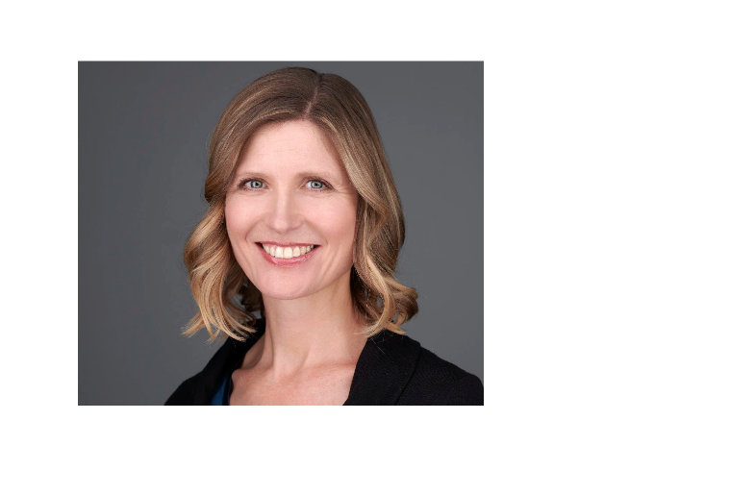

Natalie Reitman-White, Principal at Purpose Owned, LLC. Natalie is a leader and change maker, nationally recognized for her work on transformative ownership and investment models. Natalie has over two decades of experience as an executive in the food sector, developing and leading strategic initiatives in sustainable business, trade advocacy, organizational development, governance and human resources. In 2018, she pioneered one of the first-in-the-nation Perpetual Purpose Trust ownership transitions with Organically Grown Company. Following that she co-founded and spent 5 years at Alternative Ownership Advisors, specializing in business ownership succession strategies. She is a sought-after educator and consultant, helping dozens of business owners to explore and implement tailored ownership succession solutions to help them protect their legacy by ensuring their companies stay value-driven and benefit their stakeholders into the future. She is currently the Board President of the Purpose Trust Ownership Network, a not-for-profit organization dedicated to supporting the growth of purpose trust ownership and employee ownership trusts in the United States.

